ABP/WAS-001

Anti-Bribery Policy

ANTI-BRIBERY & CORRUPTION STATEMENT
W A Styles Limited is committed to applying the highest standards of ethical conduct and integrity in its business activities in the UK. Every employee and individual acting on our behalf is responsible for maintaining W A Styles Limited’s reputation and for conducting company business honestly and professionally.
W A Styles Limited considers that bribery and corruption has a detrimental impact on business by undermining good governance and distorting free markets. The Company benefits from carrying out business in a transparent and ethical way and helping to ensure that there is honest, open and fair competition in the construction industry. Where there is a level playing field, W A Styles Limited can lead the market by delivering excellent quality services to our customers.
Transparent and fair conduct helps to foster deeper relationships of trust between W A Styles Limited and its business partners and customers. It is vital for the organisation's reputation and future growth.
W A Styles Limited does not tolerate any form of bribery, whether direct or indirect, by, or of, its employees, clients, agents or consultants or any persons or companies acting for us or on our behalf. The senior management are committed to implementing and enforcing effective systems throughout the organisation to prevent, monitor and eliminate bribery, in accordance with the Bribery Act 2010.
We have issued this anti-bribery policy outlining W A Styles Limited’s position on preventing and prohibiting bribery and circulated this information in the form of a toolbox talk to all employees. The anti-bribery policy will from now on form part of our company induction procedures. The anti-bribery policy applies to all employees, as well as agency workers, consultants and contractors, in the UK. All employees and other individuals acting for W A Styles Limited are required to familiarise themselves and comply with the organisation's anti- bribery policy with immediate effect.
A bribe is a financial advantage or other reward that is offered to, given to, or received by an individual or company (whether directly or indirectly) to induce or influence that individual or company to perform public or corporate functions or duties improperly. Employees and others acting for or on behalf of the organisation are strictly prohibited from making, soliciting or receiving bribes or unauthorised payments.
As part of its anti-bribery measures, the organisation is committed to transparent, proportionate, reasonable and bona fide hospitality and promotional expenditure. Such expenditure must be authorised in advance, in accordance with W A Styles Limited’s management procedures.
A breach of our anti-bribery policy by an employee will be treated as grounds for disciplinary action, which may result in a finding of gross misconduct, and immediate dismissal. Employees and other individuals acting for W A Styles Limited should note that bribery is a criminal offence that may result in up to 10 years' imprisonment and/or an unlimited fine for the individual and an unlimited fine for the organisation. Where found, WA Styles Ltd will inform the Police of any acts of bribery or corruption.

The Company will not conduct business with service providers, agents or representatives that do not support W A Styles Limited’s anti-bribery objectives. We reserve the right to terminate contractual arrangements with any third parties acting for, or on behalf of, W A Styles Limited with immediate effect where there is evidence that they have committed acts of bribery.
The success of W A Styles Limited’s anti-bribery measures depends on all employees, and those acting for the organisation, playing their part in helping to detect and eradicate bribery. Therefore, all employees and others acting for, or on behalf of, W A Styles Limited are encouraged to report any suspected bribery in accordance with the procedures set out in the anti-bribery policy. W A Styles Limited will support any individuals who make such a report, provided that it is made in good faith.
This policy will be regularly monitored to ensure that the objectives are achieved. It will be reviewed Annually and, if necessary, revised in the light of legislative or organisational changes.

Signature: | Date: 17-07-24
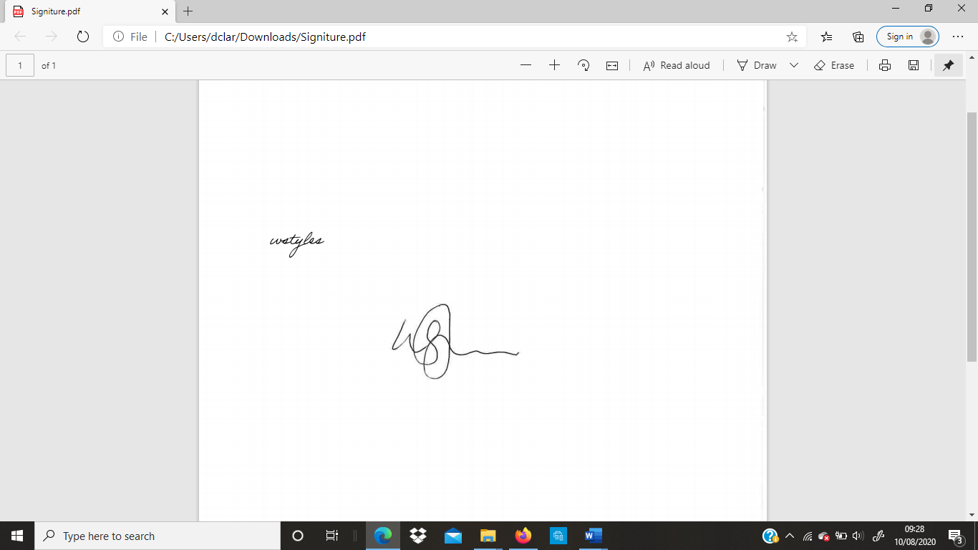
Name: William Styles | Position: Director
ABP/WAS-001
----------------------------------------------------------------------------------------------------------------
Declaration:
I can confirm that the WA Styles Ltd.’s Anti Bribery & Corruption Policy has been explained, and a copy of this policy has been supplied to me. I will abide by all the information contained within this document and can confirm I have read and understand all the information supplied within.
NAME:
SIGNATURE:
DATE:

