MODERN DAY SLAVERY AND HUMAN TRAFFICKING POLICY
WA Styles Ltd is committed to driving out acts of modern-day slavery and human trafficking within its business and that from within its supply chains, including sub-contractors, and partners. The Company acknowledges responsibility to the Modern Slavery Act 2015 and will ensure transparency within the organisation and with suppliers of goods and services to the organisation.

WA Styles Ltd commits to taking all necessary steps to ensure the workforce we and our suppliers engage is free from effects associated with modern slavery, human trafficking, forced our bonded/imprisoned labour. We will conduct right to work checks on every employee within its employment at induction. We expect all our supply chain to perform the same checks in accordance with the Immigration, Asylum and Nationality Act 2006.

As part of the company’s due diligence processes into slavery and human trafficking the supplier approval process will endeavour to incorporate a review of the controls undertaken by the supplier. Imported goods from sources from outside the UK and EU are potentially more at risk for slavery/human trafficking issues. The level of management control required for these sources will be continually monitored.
The company will not support or deal with any business knowingly involved in slavery or human trafficking, forced or bonded labour.
The company Directors and senior management shall take responsibility for implementing this policy statement and its objectives and shall provide adequate resources (training, etc) and investment to ensure that slavery and human trafficking is not taking place within the organisation and within its supply chains.
A full copy of this policy and a copy of the Modern Slavery Act 2015 will be accessible to all employees electronically and can be obtained from the office manager upon request.
This Policy takes into account, and supports, the policies, procedures and requirements documented in our Integrated Management System. The implementation and operation of this management system underlines our commitment to this policy. Formal procedures concerning slavery and human trafficking have been established, including disciplinary procedures where they are breached. Additional procedures ensure that this policy is understood and communicated to all levels of the company, and that it is regularly reviewed by the Directors to ensure its continuing suitability and relevance to the company activities. Details of this policy will be made available as part of the company induction procedures.
This policy will be regularly monitored to ensure that the objectives are achieved. It will be reviewed annually and, if necessary, revised in the light of legislative or organisational changes.

Responsibility for reporting incidents of slavery
The detection and reporting of slavery is the responsibility of us all. You should raise any concerns about any issue or suspicion of modern slavery in any part of our business or supply chain at the earliest possible stage.

- Speak confidentially to the Office Manager, Supervisor, or Director.
Signature: | Date: 17-07-24
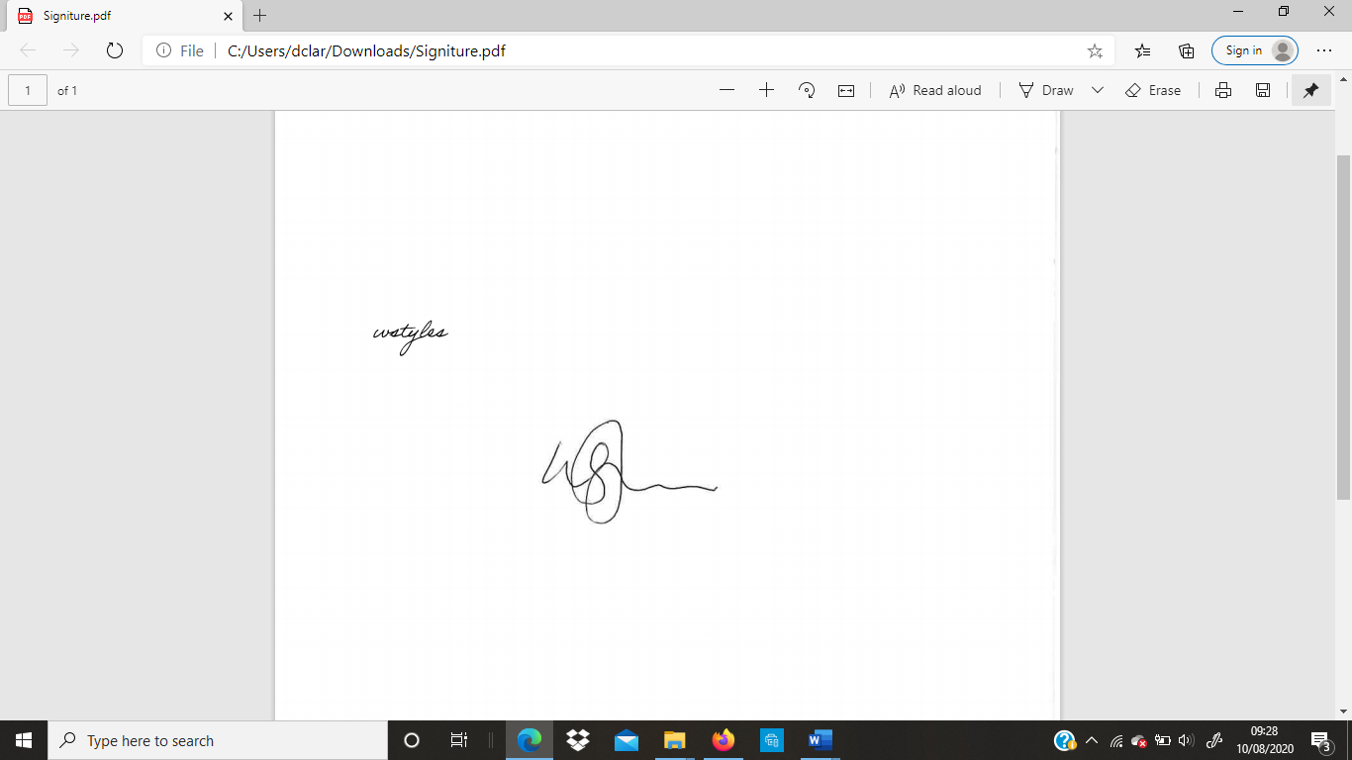
Name: William Styles | Position: Director

